**Mongo DB Task Day - 2**

Database for Guvi Zen Class. This database has the following Collections.

1. Codekata
2. Attendence
3. Companydeirves
4. Mentors
5. Tasks
6. Topics
7. Users

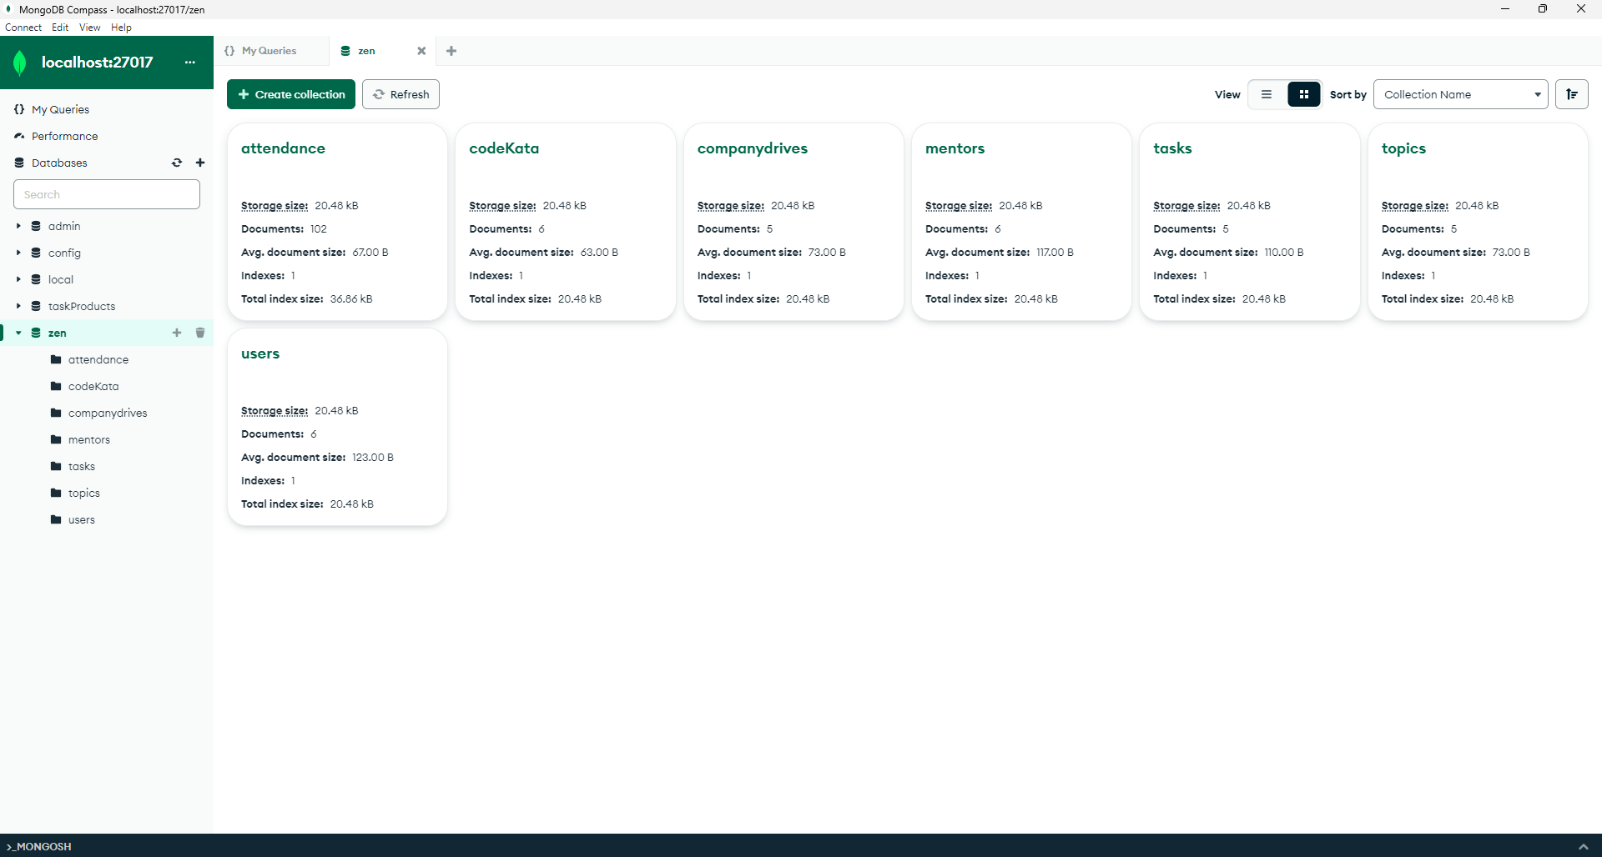

1. **Find all the topics and tasks which are taught in the month of October?**

Ans:

db.topics.aggregate(

[

{ $lookup: { from: "tasks", localField: "topicid", foreignField: "topicid",

as: "taskinfo" } },

{ $match: { $and:

[ { topic_date: { $gte: new Date("2020-10-01"), $lt: new Date("2020-11-01") } }

{ $or:

[ { "taskinfo.due_date": { $gte: new Date("2020-10-01"), $lt: new

Date("2020-11-01") } }, { "taskinfo.due_date": { $exists: false } }

]

}

] } },

{ $project: { _id: 0, topicid: 1, topic: 1, topic_date: 1, tasks: "$taskinfo.task",

due_dates: "$taskinfo.due_date" } }

])



1. **Find all the company drives which appeared between 15 oct-2020 and 31-oct-2020?**

Ans:

db.companydrives.find( { $or: [ { drive_date: { $gte: new Date("15-oct-2020") } },

{ drive_date: { $lte: new Date("31-oct-2020") } }

] } )

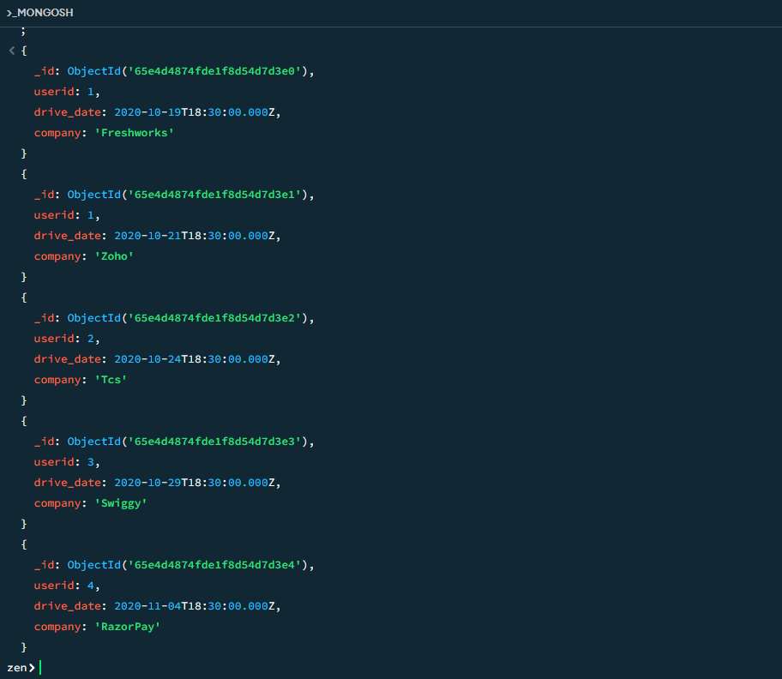

1. **Find all the company drives and students who are appeared for the placement?**

Ans:

db.companydrives.aggregate( [ { $lookup: { from: "users", localField: "userid",

foreignField: "userid", as: "userinfo" } },

{ $project: {_id: 0, company: 1, drive_date: 1,

students: "$userinfo" } }

] )

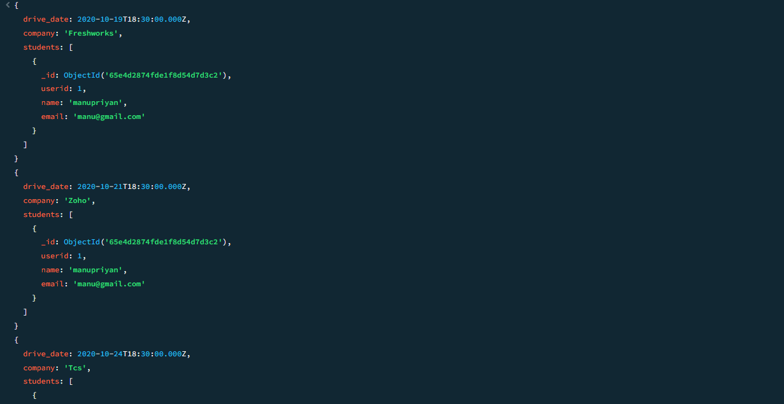

**4)Find the number of problems solved by the user in codekata?**

**Ans:**

db.codekata.aggregate(

[ { $lookup: { from: "users", localField: "userid",

foreignField: "userid", as: "userinfo" } },

{ $group: { _id:{userid: "$userid",username: "$userinfo.name" },

total_problems_solved: { $sum: "$problems" } } },

{ $project: {_id: 0, userid: "$_id.userid", username: "$_id.username",

total_problems_solved: 1 } }

])

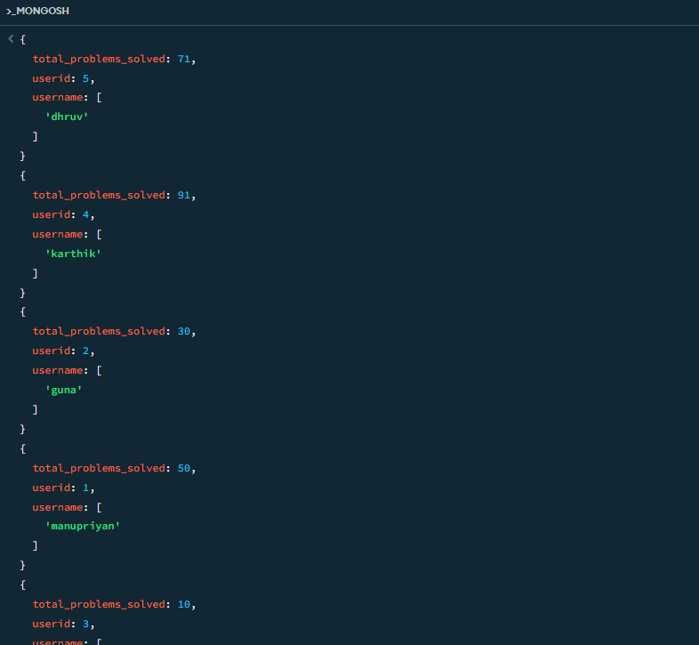

**5)Find all the mentors with who has the mentee's count more than 15 :**

Ans:

db.mentors.aggregate(

[ { $match: { mentorid: { $exists: true } } },

{ $group: {_id: "$mentorid", mentorname: { $first: "$mentorname" },

mentee_count: { $sum: 1 } }

},

{ $match: { mentee_count: { $gt: 15 } } },

{ $project: { _id: 0, mentorid: "$_id", mentorname: 1, mentee_count: 1 } }

])

**6)Find the number of users who are absent and task is not submitted  between 15 oct-2020 and 31-oct-2020 :**

Ans:

db.attendance.aggregate(

[

{ $lookup:{ from: "topics", localField: "topicid", foreignField: "topicid", as: "topics" }

},

{ $lookup: { from: "tasks", localField: "topicid", foreignField: "topicid", as: "tasks" }

},

{ $match: { attended: false, "tasks.submitted": false, $and:

[ { "topics.topic_date": { $gte: new Date("15-oct-2020") } },

{ "topics.topic_date": { $lte: new Date("31-oct-2020") } },

{ "tasks.due_date": { $gte: new Date("15-oct-2020") } },

{ "tasks.due_date": { $lte: new Date("31-oct-2020") } }

] }

},

{ $count: "No_of_students_absent"}

])